UHU024

DESIGN THINKING

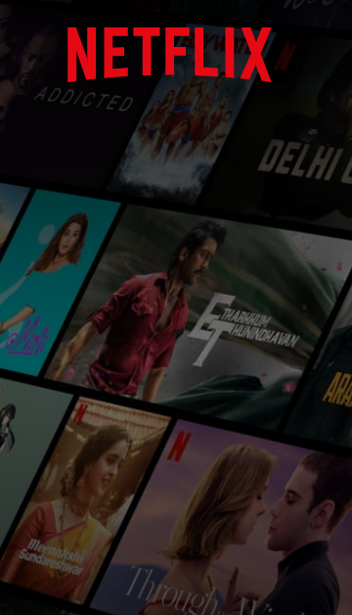Submitted To: Dr.Gurvinder Kaur,Dr.Anupam

Case study on

By: Divija 102018056 CSBS-3

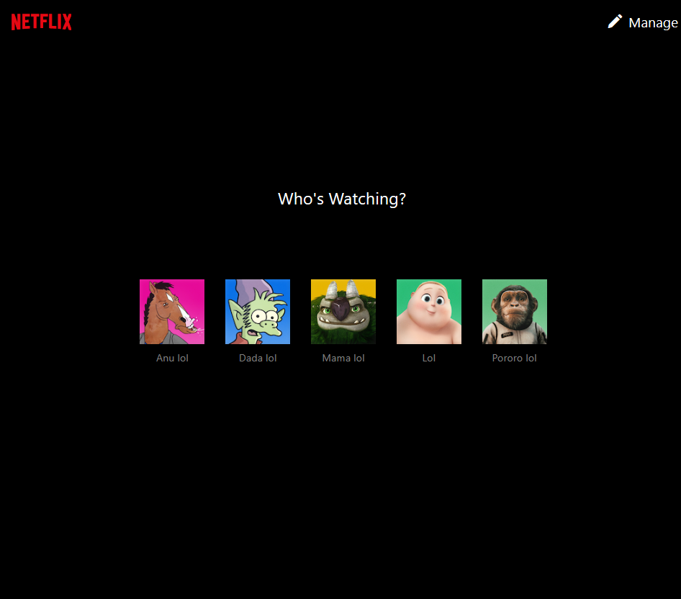

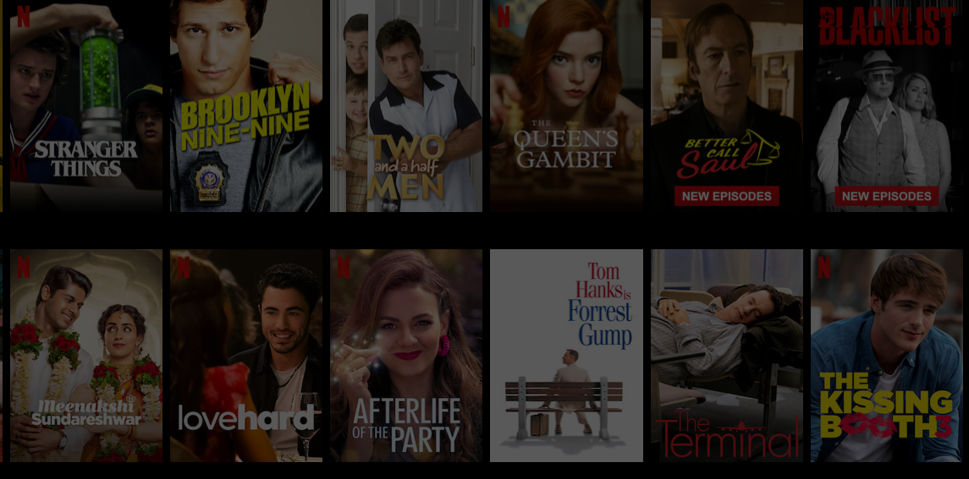

Future thoughts

Success story

Application

Evolution

Introduction

Introduction

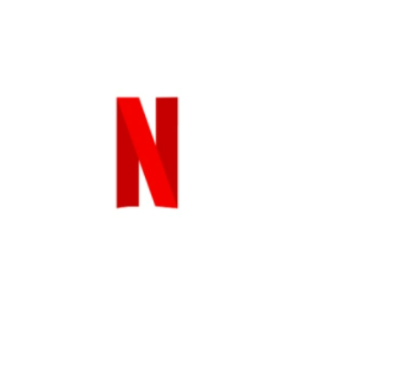When you think about searching online, you think Google. And when you think about binge-watching series and movies you think of……right: Netflix. Netflixing has become synonymous to **binge-watching**. It offers films and TV series commercial-free and unlimited viewing on any internet-connected screen for an affordable, no-commitment monthly fee.

Netflix can be accessed via internet browser on computers, or via application software installed on smart TVs, set-top boxes connected to televisions, tablet computers, smartphones, digital media players etc.

Now talking about the **logo design**, the N represents connection and a never-ending stream of stories to our subscribers. Simple and iconic, it instantly sparks brand recognition. The N symbol colour palette always consists of two tones. This helps give it dimension and differentiate from the N within the full Netflix logo. The primary background for the N symbol is black. This is to emulate a premium cinematic feel as we continue to set the industry standard for original content.

Whatever your taste, and no matter where you live, Netflix gives you access to best-in-class TV series, documentaries, feature films and mobile games. Members control what they want to watch, when they want it, with no ads, in one simple subscription. We’re streaming in more than 30 languages and 190 countries, because great stories can come from anywhere and be loved everywhere.

Most recent

Netflix Is a Joke: The Festival kicks off in Los Angeles, spanning 11 days and 295 shows, making it the biggest live, in-person event in Netflix history.

In April 2022, Netflix announced a decline in subscribers in the most recent quarter. It cited multiple factors, such as the easing of COVID-19 pandemic restrictions having reduced users, and widespread account sharing—which it deemed to be a misuse of the service.

Netflix users are watching without paying, thanks to password and account sharing. Clearly, Netflix is paying attention. In March 2022, the company announced plans to combat password-sharing, namely asking users to pay extra to allow people outside of their households to watch.

Competition

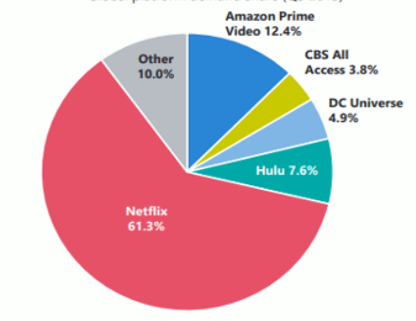Since the entertainment market is so broad, multiple firms can pay attention. Likewise, in the streaming entertainment world, HBO is quickly rising to top competitor status.

Other streaming sites such as Hulu, Amazon Prime are some of the major competitors of Netflix.

Video piracy is also a substantial competitor for entertainment time.

Movies, Shows, and Other Content

If you want shows, Netflix has over 17,000 titles globally as of April 2022.It has adult dramas like *Peaky Blinders* and *The Crown*. It also has cerebral thrillers like the German show *Dark* and *Black Mirror*. Provocative documentaries like *Thirteenth*and *When They See Us*are also available.

In case you’re searching for some lighter fare, you can giggle with *Arrested Development*or *Russian Doll*. What’s more, you can even keep the kids busy watching Netflix’s vast catalogue of anime and cartoons.

Searching for something you can watch with your *Abuela*? Want to brush up on your French?

Or then again, perhaps you simply need to perceive what sort of TV different nations are producing. Regardless, Netflix has content that appeals to a variety of backgrounds.

Dissimilar to standard TV services, you need not pay extra for this foreign-language content on Netflix.

Plans and Pricing

Its least expensive plan will cost you the cost of a film ticket. That is not a bad deal considering you’ll approach a large number of long periods of content.

It also includes recently released movies. It unquestionably costs not precisely even the least expensive conventional cable plans.

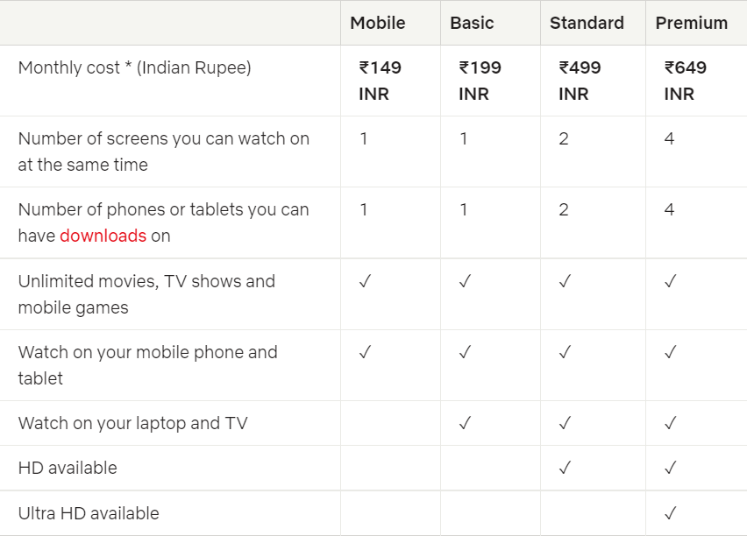

Talking about numbers

It claims the most significant share (i.e., 31% – or 6%) of total television time. This is ahead of YouTube (21%), Hulu (12%), and Amazon Prime (8%).

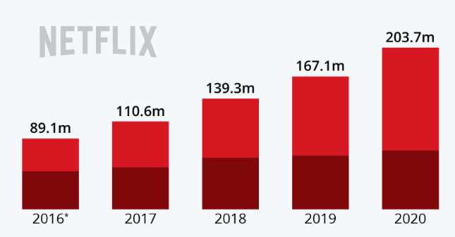The company's annual revenue in 2021 amounted to **almost 30 billion U.S. dollars**, continuing the impressive year-on-year growth

Netflix has enjoyed over the last decade.

Netflix has approximately **221.64 million** paid subscribers worldwide as of the first quarter of 2022. For perspective, Netflix competitor Hulu ended Q4 of 2021 with 43.8 million subscribers in total.

According to Forbes, back in 2001, Netflix founder Reed Hastings spent $10 million a year on streaming technology research. This fact alone shows how customer-centric Netflix has been from its very beginning.

Awards

In March 2021, Netflix earned the most Academy Award nominations of any studio with 36. Netflix won **seven Academy Awards**, which was the most by any studio. Later that year, Netflix also won **more Emmys** than any other network or studio with 44 wins.



Evolution of Netflix

It all began in April 1998, when Netflix started renting out DVDs by mail. Only a year later Netflix changed its pay-for-use model into a subscription model. Nearly a decade later, Netflix changed their proposition to a streaming service, which changed the way millions of people spend their free time

**Launch as a mail-based rental business (1997–2006)**

Netflix was a service that delivered movies to customers direct to your doorstep by mail. That was an innovative model until cable companies started offering movies on-demand. Why would someone order from Netflix and wait a few days when they could stream a movie anytime?

Initially, Netflix offered a per-rental model for each DVD but introduced a monthly subscription concept in September 1999.Netflix initially both sold and rented DVDs by mail, but the sales were eliminated within a year to focus on the DVD rental business.

**Transition to streaming services (2007–2012)**

Online streaming site-In January 2007, the company launched a streaming media service, introducing video on demand via the Internet. However, at that time it only had 1,000 films available for streaming, compared to 70,000 available on DVD.

****Development of original programming (2013–2017)**

Netflix laid stress on original content creation such as to set itself apart from the other streaming sites. Netflix entered the content-production industry in 2013, debuting its first series House of Cards.

**Expansion into international productions (2017–2020)**

In November 2017, Netflix announced that it would be making

its first original Colombian series, to be executive produced by

[Ciro Guerra](https://en.wikipedia.org/wiki/Ciro_Guerra). Netflix invested in distributing exclusive stand-up comedy specials.

**Expansion into gaming, *Squid Game* *(2021–present)***

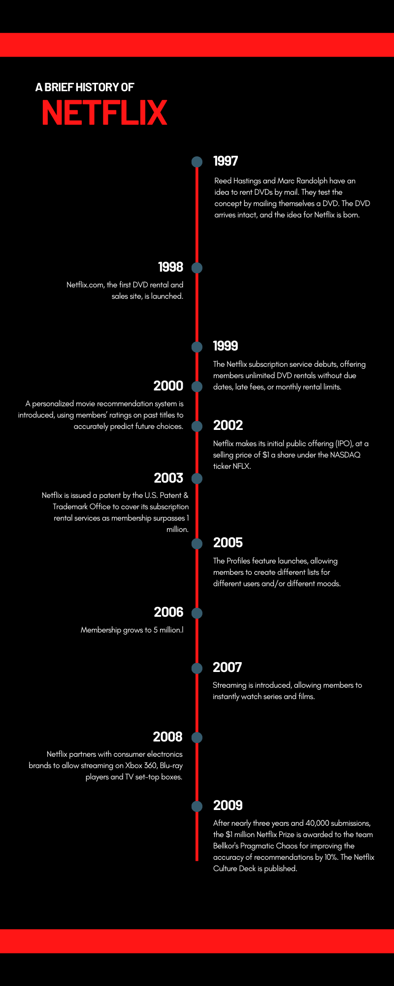

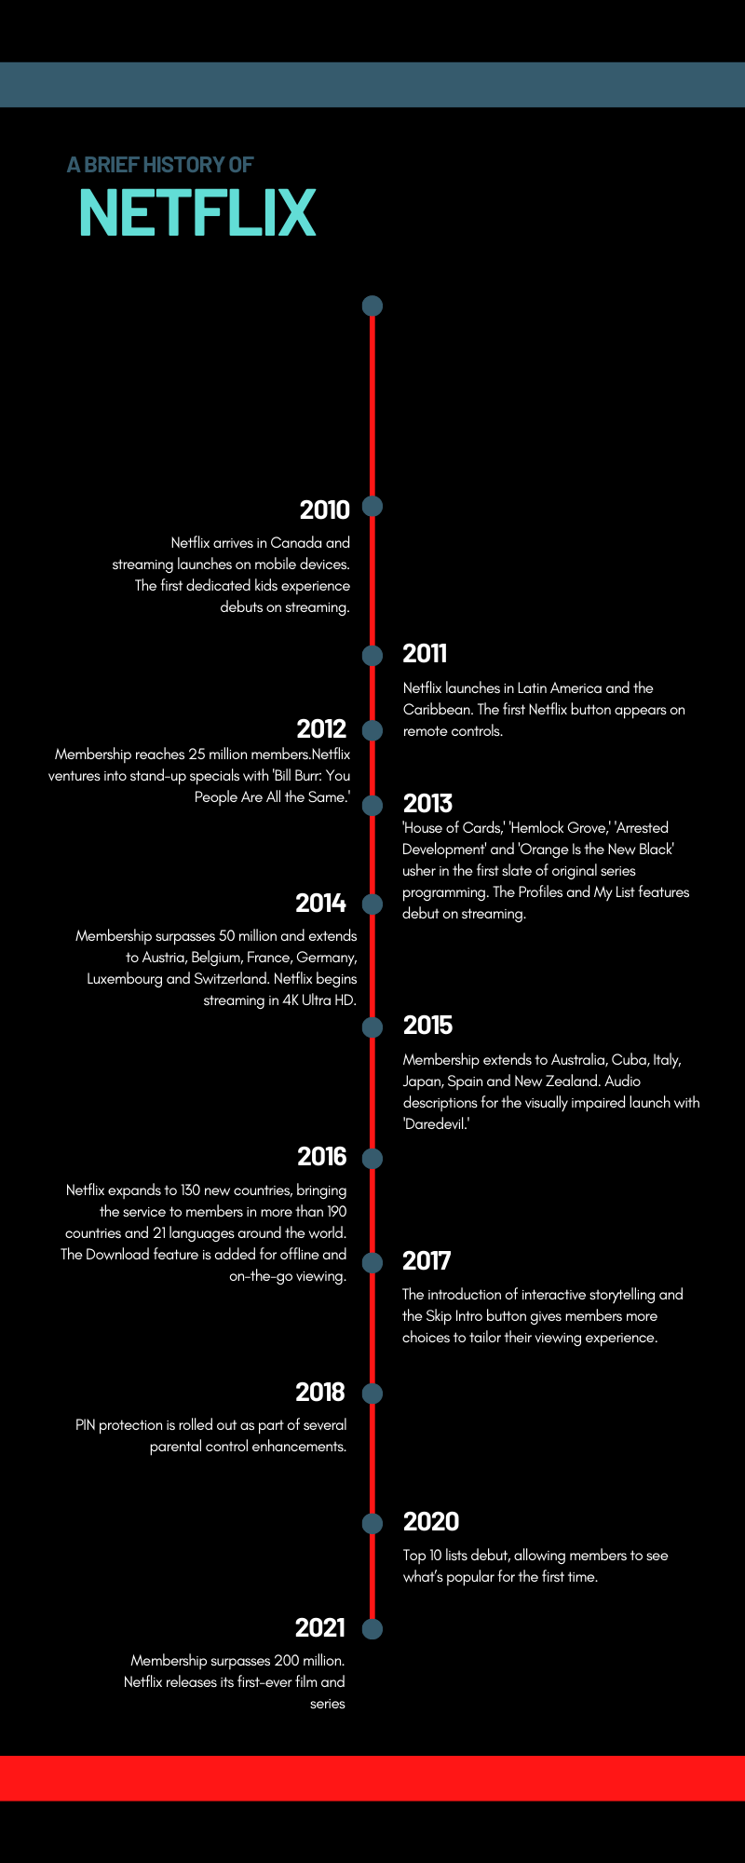

Application of Design Thinking

Netflix pivoted using design thinking to become an **on-demand streaming site** in response to cable’s competition and, more importantly, to its customer needs and expectations.

Engaging with people directly reveals a tremendous amount about the way they think and the values they hold**. Empathizing** with the customer and knowing what they want has always been the focus of Netflix.

Through surveys Netflix acknowledges and **defined** what were the challenges being faced by the users. They realized that the customer wants an application that understands them.

Some of the challenges that were faced are as following:

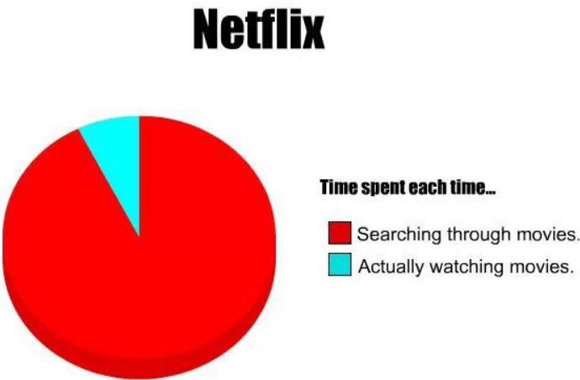Too many movies to choose from:

There are so many movies and shows offered, that viewer cannot select quickly. Users are confused between the selection which causes them to spend a lot of time in just choosing. This problem hinders the watching experience of user, they are uncomfortable in starting a new movie.

Display of Inappropriate content:

Keeping in mind the interests of everyone, all kinds of shows and movies are produced. However this is a major concern for parents as this can be a problem for children. Viewing inappropriate content can put bad influence on their children.

Appealing and easy to use interface:

Netflix identifies that user wants that the software should show them what they like. Have a visual pleasant and interface which is easily navigable Customer based system of generating films will be outstanding.

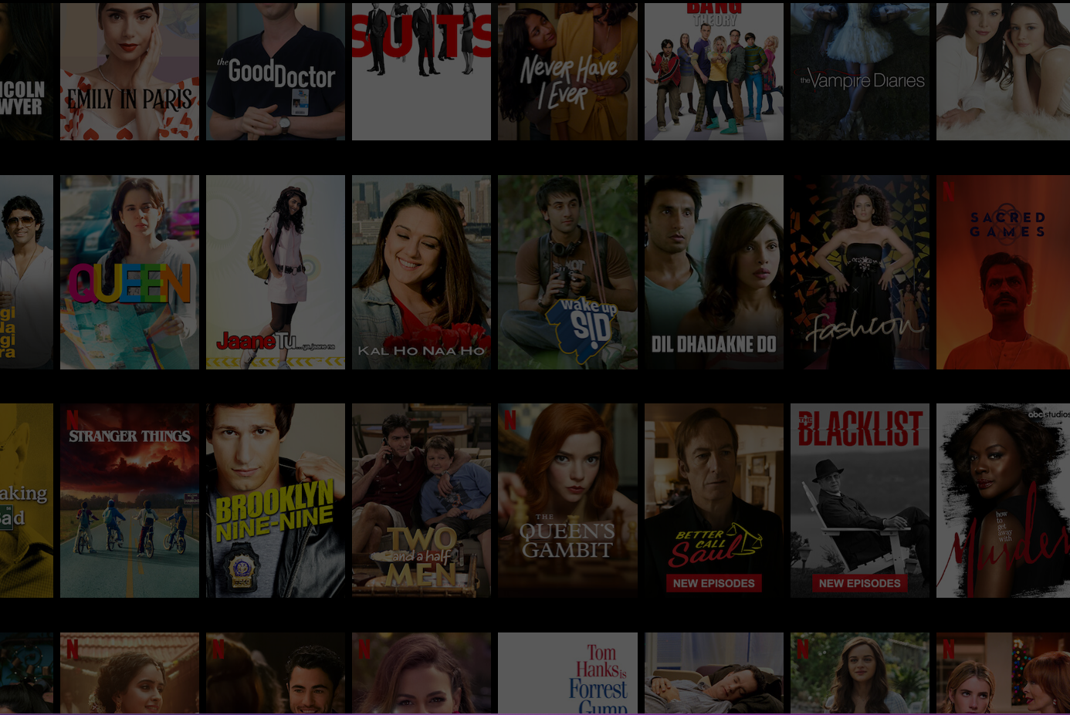

Now going through **the ideation** **phase**, to think of a solution to handle the difficulty in choosing a film, Netflix ask themselves many questions and create the observation of:

**User’s past behaviour** to predict which other things that user will like; how much people will watch a movie based on their movie preferences. Netflix takes into consideration-How to **improve the watching** experience? By making recommendation of movies.  
What can we do to easily navigate users to their potential favourite? To make it easy, catch their user’s attention platform should be simple and easily navigable.

What are some of the ways to **predict user’s preferences**? Netflix thought the use of algorithms. How to provide more **user-friendly content**? By differentiating between the users-the concept of different profiles solves the problem. Different profile for kids can be created so that parents can be relaxed while their kids are using the application.

Netflix developed their **prototype tests** by trying different options of thumbnail, to see which one would attract more attention  
However, each Netflix user is different when it comes to preferences thus Netflix also had to take into consideration and develop each suitable thumbnail for different tastes and likes.

Back **testing** to test the outcome of the recommendation system, Netflix brought upon three types of evaluation:

User studies: on small scale, judging the recommendation  
Online evaluations (a/b tests): 1000 of users of the real product are involved, the effectiveness of the measure talks about the diversity, accuracy of recommendation

Offline evaluations: are ways of historic data, a data set compiling how did user watch in the past, knowing their preferences and matching with the predications by the algorithm

Netflix: A Success

Netflix is an inspirational example of company that successfully shifted their business multiple times and grew exponentially. Growth requires innovation, and innovation is derived by design thinking.

**Personalized Content**

 No one needs to sit around idly on the things which they don’t like. Netflix has constantly thought about users’ satisfaction as their top priority.

Netflix makes the content according to the client’s wants. Afterward, they gather data about users’ ratings and recommend more shows and movies to subscribers. Netflix developed their prototype tests by trying different options of thumbnail , to see which one would at tract more attention.

**Ad-Free Content**

When viewing a video on YouTube, you can comprehend how online advertisements can hinder user experience. Netflix understands this, and they seem to be entirely satisfied to not display advertisements for the time being.

If they ever did decide to air advertisements, it would likely be similar to how HBO serves ads to their users, with one quick commercial for an upcoming original show or film.

**Original Content**

Netflix included another differentiator in 2012: original content. *Lilyhammer* drove the charge in 2012. However, it was *Orange Is the New Black* and *House of Cards*, both launched in 2013, that truly made a monumental difference.

**Netflix App**

Netflix is extraordinary compared to other online players that you will ever see with the online streaming services. It approaches a fascinating procedure known as “Chaos Engineering.”

This brings down one of the three of Amazon’s data canters on which the Netflix application works. It then diverts the traffic to two different areas. Through this procedure, everything is smooth when anybody is watching Netflix.

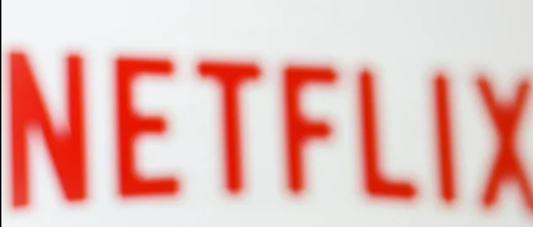

Thoughts about the future of the company

To begin with, look at the user-focused approach followed by Netflix and how they continue to emerge to face the competition in the market.

Netflix has proven the business model, albeit they have had some tough years as one might point out. In many ways Netflix is a household brand. Older generations are embracing the service as smart TVs become more commonplace in our living rooms. The younger generations, in many cases, subscribe solely to Netflix without any cable subscription. I think, therefore, Netflix will continue to grow and I see the following future playing out over the next decade:

**Internet Streaming of Content, Specifically Netflix, Continues to Grow, Ultimately Becoming the Fastest Growing Subscription Service.**As the marketplace continues to be flooded with generations of consumers who were raised with smartphones in their hands, the demand for streaming services like Netflix will grow, ultimately growing at a faster rate than cable providers as consumers look for an on-demand model for content.

**Large Players in the Media Field Become Content Sponsors.**Companies like Netflix and other media companies including Apple will produce "original" content using traditional production methods, but will skip traditional broadcasting methods and instead release direct to Netflix. Big Hollywood names will begin to penetrate this market and the first large production studio will release the first full-length film direct to Netflix, charging customers a "early bird" fee to watch the movie.

**Streaming Boxes will Replace Cable Boxes in the Living Room.**As online streaming begins to dominate the marketplace, cable boxes will ultimately be replaced by streaming media devices like Roku and Apple TV. The larger providers will create "custom channels" on their streaming boxes for consumers to subscribe to, allowing consumers to customize the content they are paying for.

Although there’s **increased competition**, Netflix saw a decrease in customers and failing of share prices. But Netflix will continue to produce content to retain and gain customers for the foreseeable future. Investors and traders, knowing this, will continue to buy and sell NFLX stock for the foreseeable future as well.

We all know that a **customer is a key part** of any business to achieve success, and if the company succeeds in keeping the customer engages with their product for the best time, nothing can stop them from increasing their revenue. The internet is getting faster and more reliable, while penetration of connected devices, like smart TVs and smart phones is also rising. There is more freedom and flexibility, consumers can watch whatever they want.

Netflix knows exactly what customers want, when they want it and how to serve them. Rapid innovation of app is there, frequent improvement updates by keeping in mind the needs of user are being done.

Because let's be real, there's "Chill" and then there's "Netflix and Chill"



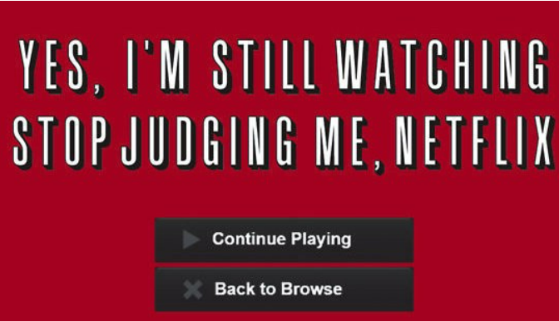

Thank you